**Android**

Android is an operating system that is built basically for Mobile phones. It is based on the Linux Kernel and other open-source software and is developed by Google. It is used for touchscreen mobile devices such as smartphones and tablets. But nowadays these are used in Android Auto cars, TV, watches, camera, etc.

**1. Android Programming Languages**

In Android, basically, programming is done in two languages JAVA or C++ and XML(Extension Markup Language). Nowadays KOTLIN is also preferred.

**2. Android Components**

The four major app components are:

* **Activities**
* **Services**
* **Broadcast Receivers:**
* **Content Provider**

**3. Structural Layout Of Android Studio:**

**Manifest Folder: Android Manifest**is an XML file that is the root of the project source set. It describes the essential information about the app and the Android build tools, the Android Operating System, and Google Play. It contains the permission that an app might need in order to perform a specific task.

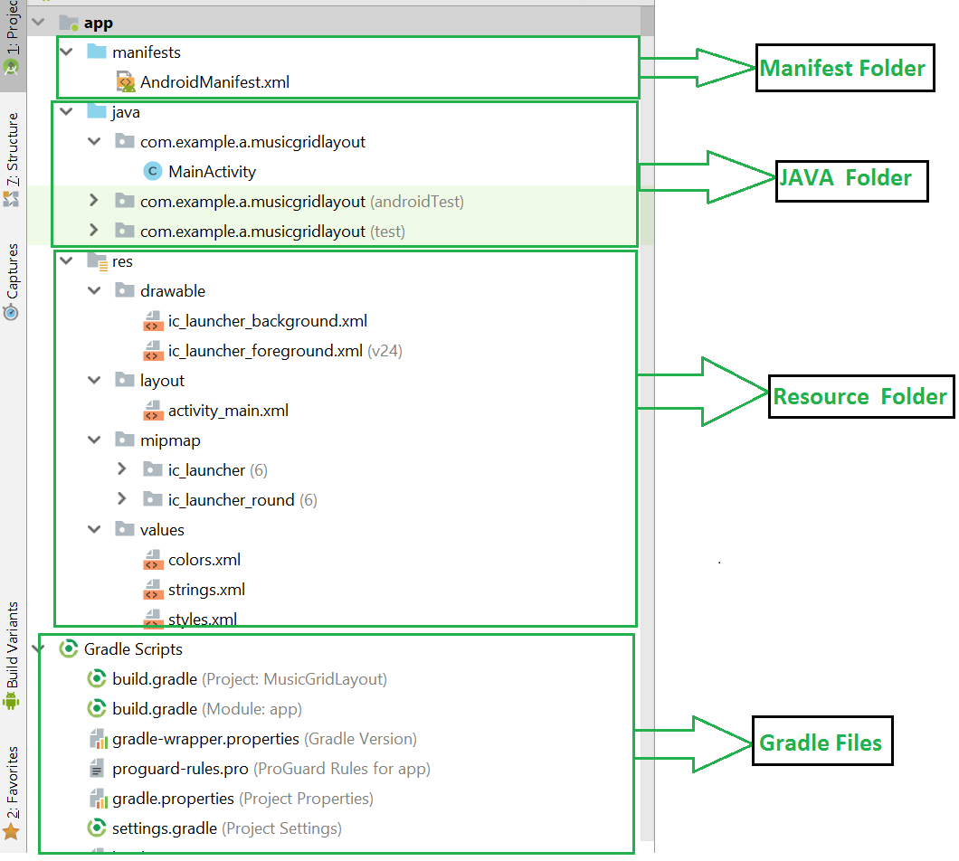

**Java Folder**: The JAVA folder consists of the java files that are required to perform the background task of the app. It consists of the functionality of the buttons, calculation, storing, variables, toast(small popup message), programming function, etc.

**Resource Folder:** The res or Resource folder consists of the various resources that are used in the app. This consists of sub-folders like drawable, layout, mipmap, raw, and values. The drawable consists of the images. The layout consists of the XML files that define the user interface layout.

**Gradle Files:** Gradle is an advanced toolkit, which is used to manage the build process, that allows defining the flexible custom build configurations. Each build configuration can define its own set of code and resources while reusing the parts common to all versions of your app.

**android architecture**

The main components of android architecture are following:-

* Applications
* Application Framework
* Android Runtime
* Platform Libraries
* Linux Kernel

**Android developer tools**

The android developer tools let you create interactive and powerful application for android platform. The tools can be generally categorized into two types.

* SDK tools
* Platform tools

**What is the Android Application Package (APK)?**

Android Application Package or APK can be thought of as a package installer file for the Android operating system. In any other application you develop, the end product of that application is APK. Using the APK, the users can install your application on their device and can operate it.

**Features of Android:**

* Beautiful UI
* Connectivity
* Storage
* Media support
* Messaging
* Web browser
* Multi-touch
* Multi-tasking
* Multi-Language
* Wi-Fi Direct
* Android Beam

**Application sandboxing**

Application sandboxing is a software development approach to limit the environments in which certain code can execute for improved safety. Learn more here.

**CHP 02**

***Activity :***

An activity is the single screen in android. It is like window or frame of Java.

Android Activity Lifecycle methods

Let's see the 7 lifecycle methods of android activity.

|  |  |
| --- | --- |
| **Method** | **Description** |
| **onCreate** | called when activity is first created. |
| **onStart** | called when activity is becoming visible to the user. |
| **onResume** | called when activity will start interacting with the user. |
| **onPause** | called when activity is not visible to the user. |
| **onStop** | called when activity is no longer visible to the user. |
| **onRestart** | called after your activity is stopped, prior to start. |
| **onDestroy** | called before the activity is destroyed. |

**UI screen components**

A typical user interface of an android application consists of action bar and the application content area.

* Main Action Bar
* View Control
* Content Area
* Split Action Bar

**View and ViewGroups**

A view is just a widget that appears on the screen. It could be button e.t.c. One or more views can be grouped together into one GroupView. Example of ViewGroup includes layouts.

**Types of layout**

There are many types of layout. Some of which are listed below −

* Linear Layout
* Absolute Layout
* Table Layout
* Frame Layout
* Relative Layout

**Android Fragment**

Android Fragment is the part of activity, it is also known as sub-activity. There can be more than one fragment in an activity. Fragments represent multiple screen inside one activity.

**Android Intent:**

Android Intent is the message that is passed between components such as activities, content providers, broadcast receivers, services etc.

Android intents are mainly used to:

* Start the service
* Launch an activity
* Display a web page
* Display a list of contacts
* Broadcast a message
* Dial a phone call etc.

**Types of Android Intents**

There are two types of intents in android: implicit and explicit.

1) Implicit Intent

Implicit Intent doesn't specifiy the component. In such case, intent provides information of available components provided by the system that is to be invoked.

2) Explicit Intent

Explicit Intent specifies the component. In such case, intent provides the external class to be invoked.

1. Intent i = **new** Intent(getApplicationContext(), ActivityTwo.**class**);
2. startActivity(i);

### **Notification:**

As a first step is to create a notification builder using *NotificationCompat.Builder.build()*. You will use Notification Builder to set various Notification properties like its small and large icons, title, priority etc.

NotificationCompat.Builder mBuilder = new NotificationCompat.Builder(this)

### **Properties**

Once you have **Builder** object, you can set its Notification properties using Builder object as per your requirement. But this is mandatory to set at least following −

* A small icon, set by **setSmallIcon()**
* A title, set by **setContentTitle()**
* Detail text, set by **setContentText()**

mBuilder.setSmallIcon(R.drawable.notification_icon);

mBuilder.setContentTitle("Notification Alert, Click Me!");

mBuilder.setContentText("Hi, This is Android Notification Detail!");

**Content providers**

Content providers let you centralize content in one place and have many different applications access it as needed. A content provider behaves very much like a database where you can query it, edit its content, as well as add or delete content using insert(), update(), delete(), and query() methods. In most cases this data is stored in an SQlite database.

**Database – Creation:**

SQLiteDatabase mydatabase = openOrCreateDatabase("your database name",MODE_PRIVATE,null);

**Chp 06**

Setting up the target app and analyzing the app using drozer,

**Drozer** is an android application security testing framework which is developed by FSecureLABS that makes it easy for a Pen-tester to check for potential vulnerabilities in the components of an application. It was in the past known as Mercury. It Works by playing the part of a local Android application and interfacing with the Dalvik Virtual Machine.

Features:

* Static Analysis
* Run time Manipulation
* Information Gathering
* Enumeration of Packages

**What is WebView**

WebView is a view that displays web pages within your existing android application without the need for opening links in an external browser.

**SQL injection**

SQL injection is a code injection technique that might destroy your database. SQL injection is one of the most common web hacking techniques.

**Man-in-the-Middle (MitM) attacks:**

A man-in-the-middle (MITM) attack is a type of cyberattack where attackers intercept an existing conversation or data transfer, either by eavesdropping or by pretending to be a legitimate participant.

**Log analysis**

Log analysis is the process of reviewing computer-generated event logs to proactively find bugs, security threats or other risks.